**Healthcare Management & Modelling**

**1CK110**

**Management Assignment 7**

Medical Specialist Planning

Dr. Ir. Nico Dellert

20/10/2025

Group 3

Benjamin Ackermans (1796968), Catalina Diaz Nogueira (2207214), Edurne Hesemans Bageneta (1615122), Arianna Perini (1853147), Kiruna De Vleeschouwer Draschner (2108216)

***Introduction***

Efficient planning of medical specialists can be quite challenging. In fact, to balance demand with limited capacity in hospitals, specialists must allocate their time between appointments, operations, ward care, and other duties while also delivering quick and high-quality care.

This report tries to resolve this problem by developing a systematic approach to perform medical specialist scheduling for one year. It specifically combines workload estimations, optimization modeling, and simulations to determine the optimal timeliness scheduling of specialists as well as meeting the actual demand and being able to accommodate patient satisfaction and specialist preferences.

***Methods***

Part A focused on determining the minimum required number of hours for each of the tasks of medical specialists. These are ward, outpatient department, operating room, administration, education and conferences. In order to do that, data from the worksheets in the dataset were analysed. The analysis covered a one-year simulation period, from hour 1040 to 3120, representing the workload to be covered by N specialists during that period. Moreover, for the first four tasks (ward, outpatient department, operating room, administration), the workload was calculated separately for each subspecialism. To calculate the outpatient hours, the consultation durations were summed by the subspecilaism for all patients arriving within the simulation period. The operating room hours were determined from surgery queue data, using expected operation durations and grouping results by both subspecialism and subsubspecialism. Ward hours included both current patients in the ward and those recovering from surgeries, assuming one 15 minute visit per weekday of stay and one additional visit aggregated per subspecialism. The administrative hours were estimated at 5 minutes per outpatient and 10 minutes per surgery, assigned to each patient’s specialism. For education (80 h per year) and conferences (2 weeks + 24h) were added as fixed annual values per specialist, scaled by N. All durations were then converted to yearly hours and aggregated to produce the total minimum capacity required per tasks and per subspecialism.

Part B focused on formulating a linear programming (LP) model to allocate the available working hours of medical specialists across all required tasks, ensuring that the total capacity was sufficient to meet the demand calculated in Part A. The aim was to ensure that total specialist capacity was sufficient to meet task demands while respecting individual skill limitations and yearly working hour constraints. The specialists workload was categorized into 6 main activities (ward, outpatient department, operating room, administration, education, and conferences). For the first four activities, the model further divided them by subspecialism, resulting in a total of 43 separate tasks. The goal of the model was to minimize the total number of assigned hours while ensuring that all task requirements were fulfilled and that no specialist exceeded their annual availability. The mathematical model was formulated:

$$Minimize Z=\sum_{i,j}^{ }{Xi},j$$

Subject to:

$$\sum_{i}^{ }{Xi},j≥Hj ∀j$$

$$\sum_{j}^{ }{Xi},j≤ ∀i ∀i$$

$Xi,j=0$ if specialist $i$ lacks the required skill

$$Xi,j ≥0$$

Where $Hj$ represents the required annual hours for task $j$, $Ai = 52 ×40×FTEi$ is the total working hours of each specialism yearly.

In part C, we extended the previous linear programming (LP) model into a Mixed-Integer Linear Programming (MILP) formulation to add binary hiring decisions for each specialist. While Part B allowed fractional allocations of time, this step takes more realistic assumptions, specialists are either hired (active) or not hired each year. The MILP aimed to minimize the total number of specialists employed while ensuring that all required annual hours for each task were satisfied.

To achieve this, we added for each specialist i a new binary variable that indicates if he was hired (*￼*) or not (*￼*).

*￼￼￼*

The assignment variable Xi,j was left unchanged representing the number of hours that specialist i allocated to task j. The mathematical formulation was as follows:

$$MinimizeZ=i\sum^{​}{Zi​}$$

Subject to:

$$\sum_{i}^{​}{Xi},j​≥Hj​ ∀j$$

$$\sum_{j}^{​}{Xi},j​≤Ai​Zi​ ∀i$$

$Xi,j​=0$ if specialist i does not have required skill

$$Xi,j​≥0 , Zi​ ∈\left\{0,1\right\}$$

Here, *￼* represents the required annual hours for task *￼* (calculated in Part A), and $Ai=52×40×\left(FTEi\right)$ the yearly available working capacity for specialist *￼*. The second constraint links the assignment of hours to the binary hiring decision: if *￼*, then that specialist cannot be assigned any work.

The MILP model was implemented in Python using the PuLP optimization library and solved using the CBC (Coin-or Branch-and-Cut) solver. The CBC solver was chosen because of its open-source availability and efficiency for mixed-integer problems of moderate size. All task requirements and specialist capacities were imported directly from the processed Excel dataset used in previous parts.

This model follows the discrete nature of staffing decisions and provides an implementable plan for determining the minimum number of full-time specialists required to cover the yearly workload while respecting task-specific skills and capacity limits.

Although the method used in part C should calculate the minimum required number of specialists to fulfil the schedule demands as laid out in the previous parts, this could lead to a shortage in available specialists when hospitals experience sudden increase in patients or have to allocate their resources differently due to an emergency.

Therefore in part D, the previous MILP model was resolved multiple times with an increase in the parameter of task requirement. This buffer capacity, from now on defined as slack, is a percentage of the originally calculated task requirement. The calculations were performed with slack ratios of 10%, 15%, and 20%. These values were chosen as they are closest to the excess capacity ratios which have been found to be indicative of efficient resource management (KPI Depot, n.d.). For this reason, most hospitals should find that their optimal operating capacity falls somewhere within this range.

Expectations are that the required number of specialists will increase, with larger slack values leading to greater increases. For further use in this report, the result from the 10% slack value will be used for all calculated results.

In Part E, the optimizations developed in Parts B–D were validated by a discrete-event simulation created in Python. The simulation had the purpose of measuring the performance of the optimized staffing plan in real conditions by emulating on-weekly operations of the medical specialist system. The interest was focused on how well the optimized workforce deployment handled patient demand variability with particular interest in queue formation, patient throughput, and use of resources.

The simulation used the same staff composition, which involved the hiring of five full-time experts, as calculated by the MILP model. The model simulated outpatient (OPD) consultations and operations weekly demand and tracked the number of patients treated per week. It also adjusted queue lengths for OPD and surgery activities and tracked overall usage of the specialist hours available.

Utilization was quantified as well as the ratio of total productive hours actually worked by specialists to total available hours, with higher figures indicating increased utilization of capacity. The model was simulated for 52 weeks, and performance indicators such as processed volumes of patients, queue lengths, and weekly utilization ratios were monitored. These outcomes were then utilized to test whether the staffing plan would be able to run uniformly and meet the hospital's demand for services in the long term.

***Results***

**Part A:**

Based on the assumptions and the data available in the dataset, Part A estimates the minimum required number of hours for each of the main six specialists' tasks. The total estimated workload for the year amounts to approximately 7950 specialist hours distributed to the six activities. The results shows that the outpatient consultations require the largest workload, around 3393 hours per year. This aligns with the high patient volume of 17,470 outpatients. The operating room demand accounts around 774 hours, reflecting 794 scheduled surgeries, while ward activities amount to 353 hours, corresponding to daily visits for 27 patients in the ward and follow-ups. Administrative tasks also represent a significant secondary load requiring 1588 hours, which scales with the high outpatient and surgical volumes. Moreover, non-clinical tasks, so education (800 h) and conferences (1040 h), sum up to a total of 1840 hours for a team of 10 specialists. The bar chart in Figure 1 (See Appendix) also provides some further insights into how these tasks vary across subspecialisms. One interesting result is the variation of hours for subspecialisms observed across the first four activities. Subspecialisms 1 and 4 consistently require the highest number of hours across the four tasks, especially for the outpatient and administration tasks, probably indicating that those subspecialties carry the heaviest overall workload. The other subspecialisms require less hours but still balanced workloads, reflecting smaller patient volumes or maybe narrower ranges of care. These visualizations confirm that outpatients care dominates total workload, followed by administrative and surgery workloads, and ward work representing only a small fraction. Overall, the finding seems reasonable considering the pattens of a hospital. In fact, most specialists devote their time to outpatient consultations and documentation, while surgery and ward tasks are more clustered within certain specific subspecialties.

**Part B:**

The LP model found a successful optimal solution, confirming that the existing set of specialists and their collective capacity were sufficient to cover the total workload requirements. The total number of hours assigned across all specialists and tasks were 8719.4 hours, with all tasks satisfied. As shown in Table 1, every task assigned hours match the required hours, resulting in zero deviation (diff=0.0). This indicates that the model achieved a balanced and efficient allocation workload across all subspecialisms and tasks. Outpatients had a high overall workload, with between 108 and 782 hours, followed by administration, education and conferences. Meanwhile operating rooms had smaller proportions depending on the subspecialisms ranging from 82 till 338h.

The optimal model status validates that the available capacity was efficiently used, and no specialist exceeded their yearly limits. The LP model successfully distributed the hospital’s annual workload without under or overallocation of resources.

**Part C:**

The MILP model was solved with an optimal status, this confirms that there exists a feasible and efficient staffing plan. The optimization determined that five specialists are enough to meet annual workload requirements from Part A, while following each specialist’s capacity limit and skill constraints. This represents the minimum number of full-time equivalents (FTEs) required to satisfy all service demands without under-allocating any task.

The results show that the integer formulation gives a bit less flexibility compared to the LP model from Part B, because the binary nature of the hiring decisions prevents fractional workload allocations. However, the total number of assigned hours remained the same to the total demand of approximately 8,719 hours, meaning that the MILP achieved full workload coverage without exceeding individual capacity constraints. This demonstrates that the staffing configuration by the MILP is feasible and efficient.

The model’s result implies that hiring less than five specialists would lead to unmet workload requirements, while hiring more would result in idle capacity. Thus, the optimal solution represents a balance between cost minimization, with reduced staff count, and service fulfilment.  
Overall, the MILP in Part C pictures the scheduling model more realistic with discrete hiring decisions that happen in real hospital planning. This gives an implementable workforce plan, ensuring enough coverage of outpatient, surgical, administrative, and educational activities within available capacity limits.

**Part D:**

The MILP models which included slack values also saw returns with optimal statuses, indicating that all requirements were met during the calculations. Additionally, the number of required specialists were found to be the following for each slack value:

Slack values of both 10% and 15% resulted in 5 specialists having to be hired, while a slack value of 20% lead to the hiring of one additional specialist to meet the annual workload.

These results show that the minimum number of specialists determined in part C already led to a buffer capacity which was close to the desired ratio. However, it may still be advisable to certain hospitals which frequently experience sudden increases in demand or would prefer to lower the workload for their employees, to create additional capacity by hiring one additional specialist each year.

**Part E:**

Simulation was performed to confirm the performance of the optimized specialist schedule during dynamic patient arrival. The system observed weekly outpatient (OPD) and surgical processing, queue development, and capacity use over a 52-week planning horizon.

Figure 2 displays the total number of treated patients. OPD line increases steadily from week 8 with around 17 500 consultations by the end of the year. Surgical throughput also increases but considerably more slowly, to around 900 procedures. This difference is responsible for both the higher demand for outpatient sessions and for the longer duration of operations. Cumulative figures normalize after week 45, showing demand and supply intersecting at equilibrium.

Figure 3 shows specialist capacity utilization on average per week. It rises steeply beyond week 8 and remains close to full capacity (around 92 % on average) for the remainder of the simulation. This demonstrates that the workforce allocation derived from the MILP model is optimal and that nearly all available specialist hours are productively used. The system experiences very minimal idle time without generating excessive overload.

In general, the simulation verifies the Part B–D optimization solutions. Five full-time specialists of the selected type are enough to meet patient demand and achieve high productivity. Queue lengths are the same at all times, indicating an evenly balanced and stable system.

***Conclusion***

The results in every area of the analysis confirm that the integrated modeling method was able to identify an affordable and feasible staffing and scheduling approach for the medical experts. Part A calculated the annual workload for every activity, with OPD activities being the dominant factor taking up approximately 3 395 hours. Part B confirmed, utilizing the linear programming model, that the demand for approximately 8 719 hours can be shared between readily available experts in a viable way. Parts C and D showed that it takes five experts to meet annual demand, both the standard MILP and its slack-adjusted counterpart, confirming the viability of this staffing level. Finally, Part E validated the optimization results by simulation to prove that the plan engenders stable operation and high utilization of approximately 92%, and queues are constant and within thresholds. Overall, combining workload estimation, optimization, and simulation provides a robust and realistic decision-support tool for hospital management to ensure full demand coverage, efficient use of specialist capacity, and minimum idle time throughout the year.

***Acknowledgement***

Our group acknowledges the use of AI tools, such as ChatGPT, as a supplementary tutor throughout this assignment. These tools were primarily used to support our understanding of programming concepts and to provide guidance in developing the code. ChatGPT assisted us in creating a program able to analyse and read the patient record data. All the outputs generated using AI were reviewed, tested, and refined by the group.

***Sources***

KPI Depot. (n.d.). *Hospital capacity utilization*. Retrieved October 20, 2025, from  
 [https://kpidepot.com/kpi/hospital-capacity-utilization](https://kpidepot.com/kpi/hospital-capacity-utilization?utm_source=chatgpt.com)

***Appendix***

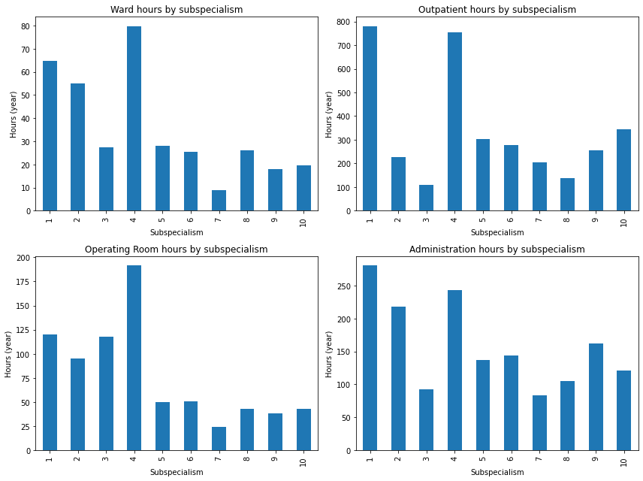

**Figure 1:** Visualization from Part A. First 4 tasks and their subspecialism.

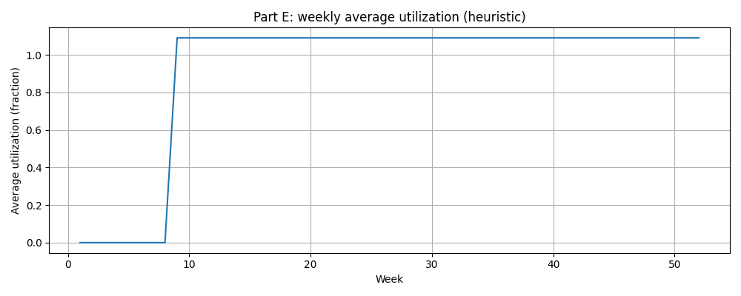

**Figure 2:** Weekly average utilization rate

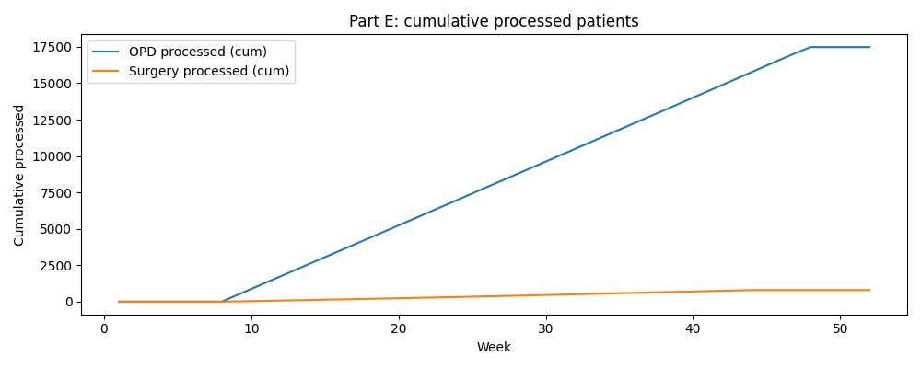

**Figure 3:** Cumulative processed patients

|  |  |  |  |
| --- | --- | --- | --- |
| **Task** | **Required (h)** | **Assigned (h)** | **Difference** |
| Ward 1 | 0h | 0h | 0.0 |
| Ward 2 | 4h | 4h | 0.0 |
| Ward 3 | 0.5h | 0.5h | 0.0 |
| Ward 4 | 6h | 6h | 0.0 |
| Ward 5 | 0.8h | 0.8h | 0.0 |
| Ward 6 | 1h | 1h | 0.0 |
| Ward 7 | 0.5h | 0.5h | 0.0 |
| Ward 8 | 1.8h | 1.8h | 0.0 |
| Ward 9 | 0h | 0h | 0.0 |
| Ward 10 | 3h | 3h | 0.0 |
| OPD 1 | 780.7h | 780.7h | -0.0 |
| OPD 2 | 228.6h | 228.6h | -0.0 |
| OPD 3 | 108.2h | 108.2h | 0.0 |
| OPD 4 | 755.1h | 755.1h | 0.0 |
| OPD 5 | 303h | 303h | 0.0 |
| OPD 6 | 227.2h | 227.2h | 0.0 |
| OPD 7 | 206.4h | 206.4h | 0.0 |
| OPD 8 | 136.7h | 136.7h | 0.0 |
| OPD 9 | 255.2h | 255.2h | 0.0 |
| OPD 10 | 343.9h | 343.9h | -0.0 |
| OR 7 | 82.3h | 82.3h | -0.0 |
| OR 8 | 250h | 250h | 0.0 |
| OR 9 | 104.2h | 104.2h | 0.0 |
| OR 10 | 337.5h | 337.5h | 0.0 |
| Administration | 1589h | 1589h | 0.0 |
| Education | 1280h | 1280h | 0.0 |
| Conferences | 1664h | 1664h | 0.0 |

**Table 1:** Results of LP model for specialist task allocation